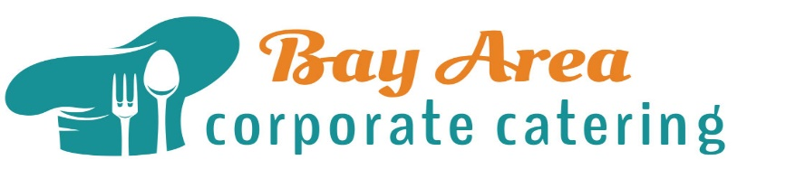
Monday August 2
Tequila Lime Chicken Fajitas
Sliced naturally raised chicken breast sautéed with peppers and onions in spicy tequila lime sauce. Avocado cilantro crema, tomatillo salsa, queso fresco, pickled jalapenos and flour tortillas.
(v) Tequila Lime Tofu Fajitas
Sliced organic tofu sautéed with peppers and onions in spicy tequila lime sauce. Avocado cilantro crema, tomatillo salsa, queso fresco, pickled jalapenos and flour tortillas.
Cilantro Corn rice & Chipotle Black Beans

Tuesday August 3
Jerk Chicken w/Papaya, Jicama, Lime & Mint
(v) Jerk Tofu & Red Beans w/ Papaya, Jicama, Lime & Mint
Spinach - Roasted Garlic Quinoa Salad

Wednesday August 4
BBQ Korean Flank Wrap Grilled and sliced
(v) Spicy Tofu Vegetable Wrap Korean inspired and loaded with crispy marinated tofu, julienne carrot, celery, cucumber, red pepper, green onion Napa cabbage, noodle and drizzled w/ Hoisin aioli and wrapped with rice paper
Brown Rice - Ginger Broccoli Salad, Veggie Pot Sticker

Thursday August 5
Roast Pork Loin French Dip
Served on sweet French roll w/ au jus dipping sauce
(v) Curry Roasted Tempeh & Vegetable & Goat Cheese Melt
Seasoned roasted Portobello, Roasted Pepper and tempeh topped w/ goat cheese served on sweet French roll
Kale Salad & Fried Plantains

Friday August 6
Coconut Shrimp w/ Summer Peach Chutney
(v) Coconut Crusted Tofu coconut and panko crusted tofu with summer peach chutney
Curry Raisin Yams & Roasted Vegetables

